Robot Chair Races

Build a robot to race around a chair. Start with a pre-designed car or build your own design. Embellish as desired (eyes, hats, tails, arms, dances, sounds, etc.).

Base designs that work are:
- Artic Ride (part of the Great Adventures unit)
- Taxi Taxi (part of the Happy Traveler unit)
- Big Little Helper (part of the Quirky Creations unit)

The robot should be able go around all four legs a chair. Extra points for difficulty.
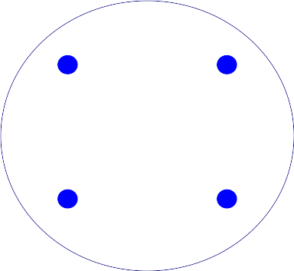  Circle 1 point | 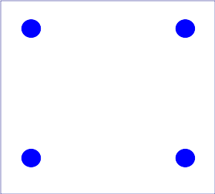  Square 2 Points | 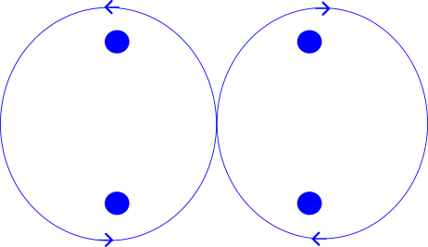  Figure 8 4 points | 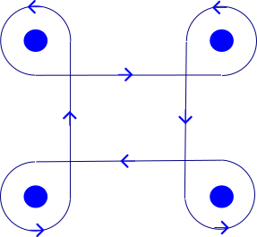  Clover Leaf 6 Points

- One point for a clean stop within 4 inches of the starting point and with all of the starting parts.
- Up to 2 style points for creativity.
Build and test your robot before asking for a timed run. Make sure the robot can complete the course without running into the chair.

Rules
- Robot can start anywhere, but it must be “outside” the chair legs. (Start line is marked with two orange cones.)
- Robot cannot be touched during its run or all points are lost.
- Program can have only a single start.
- Creative points are awarded only to robots that move under program control.
- Time is from the starting point to crossing the same line.
- Victory dances do not count toward the time, but may effect a clean stop.
- Faster times break ties.

Scoring Sheet
Contestant:

 | Run 1 | Run 2 | Run 3
Time around chair
(Smaller times are better)
Clean stop
(1 point)
Circle
(1 point)
Tight Square
(2 points)
Figure 8
(4 points)
Cloverleaf
(6 points)
Creativity and style
(up to 2 points)
Total

Notes and Comments

